Help shape our Climate and Nature Strategy

We’re developing a new Climate and Nature Strategy for Bath & North East Somerset.
Climate change and nature loss already affect us. These impacts are expected to increase over the coming years.
Use this page to tell us what matters to you or your organisation when it comes to tackling climate change and reversing nature loss in Bath & North East Somerset.

Background
The UK's climate is continuing to change. Recent decades have been warmer, wetter and sunnier than the 20th Century, and extreme weather events, including heatwaves, floods and storms, should now be expected each year.
These changes place increasing pressure on our rivers and landscapes, wildlife and green spaces, and on how we live, travel and work.
They also risk making existing inequalities worse, with some people and places more exposed to impacts and less able to adapt than others.
As a council, we have already made a commitment to tackle the Climate and Ecological Emergencies, working towards a district that is nature positive, net zero and climate resilient. Many communities, organisations, businesses and individuals are already acting at pace to tackle these emergencies too.
To make even more change happen, we need to work together. That’s why we’re asking for your views.
This survey builds on feedback gathered to date, including community conversations and a 2025 residents’ survey, and tests the priorities that we heard mattered. It will be used to further inform the new Climate and Nature Strategy, due for publication in Autumn 2026.
We want to understand:
- what a positive future looks like to you or your organisation
- whether you or your organisation agrees with ways forward we have set out
- how we make change happen, using the right priorities
Your views will help shape the strategy and the actions that follow.
This survey is open to residents, businesses, education settings, community and voluntary organisations, and anyone with a connection to Bath & North East Somerset. It takes up to 15-20 minutes to complete. You can skip questions if you wish or if there are topics you want to focus on more.
The survey is made up of four sections
Section 1: About you
Section 2: What matters for the future?
Section 3: How do we make change happen?
Section 4: Any further feedback on this subject

Alternative formats and support
If you need the survey in a different format or have any questions, contact us at Sustainability@bathnes.gov.uk

What we've done so far
We are updating our Climate and Nature Strategy, building on work that has happened since we declared Climate and Ecological Emergencies in 2019/20. Over the last few years, we have developed and delivered a range of plans and actions to respond to the emergencies. These include work on reducing emissions, restoring nature, adapting to climate impacts and supporting communities and organisations to act.
Our Climate and Nature Strategy brings that work together and looks ahead to what matters most over the next few years. It also aligns with regional and national approaches, including work with partner organisations across the West of England.

What happens next
We will combine the feedback from this survey with insights from workshops and in-person engagement. We will consider it together with previous engagement and input from partner organisations. It will inform the next draft of the Climate and Nature Strategy, which we will develop over Summer 2026.

Survey opens: Wednesday 3rd June 2026
Survey closes: Friday 24th July 2026

Section 1: About you
Q1. Which best describes you?
(select all that apply)
- I live in Bath & North East Somerset
- I run or work for a business here
- I work in an education setting
- I work for a community, voluntary or civic organisation
- I study here
- Other (please specify):

Section 2: What matters for the future?
From feedback to date, we have developed a series of 10 themes about what a positive future looks like for Bath and North East Somerset. They describe our area, once we have successfully tackled the Climate and Nature Emergencies. For each, we also set out how this could be done, at high level. We welcome your views on these.
When answering the following questions, please think about the future of Bath & North East Somerset and whether these are the right priorities to be working towards when tackling the Climate and Nature Emergencies.
For each of the 10 themes there are three steps for your feedback:
- Whether the theme description presents how you see a positive future Bath and North East Somerset, once the emergencies have been tackled
- Whether you or your organisation agrees with ways forward we have set out to get there
- Any further thoughts on this theme

The 10 themes are:
- How we travel
- The food we eat
- Our water and rivers
- Our wildlife and land
- The energy we use
- Our buildings and the built environment around them
- Our local economy, including tourism
- The resources we use and waste we produce
- How we transition fairly to living in a nature positive, low carbon, resilient place
- How we prepare for the long-term through our plans (overall)

Q2 How we travel.

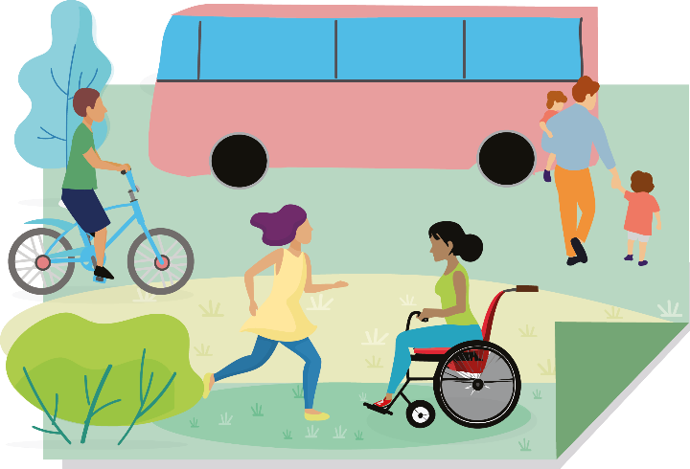

We prefer to walk, cycle or use public transport. Goods are safely moved without polluting our streets.

Q2.1 Please tell us to what extent you, or your organisation, agree that the statement above presents a positive future for Bath and North East Somerset

Please tick one:
- Strongly agree
- Agree
- Neutral
- Disagree
- Strongly disagree
- I don’t know

Q2.2 To what extent do you agree or disagree with the following ways to achieve this?
We need to:
- create sustainable places that don’t need cars
- enable people to walk, wheel, cycle and use public transport, whilst supporting nature to thrive in the way that we do this
- electrify travel. Our vehicles need to be replaced with electric ones and be charged with renewable energy

Please tick one:
- Strongly agree
- Agree
- Neutral
- Disagree
- Strongly disagree
- I don’t know

Q 2.3 Do you have any suggestions as to how you might improve the ‘How we travel’ theme?

Q3 The food we eat.
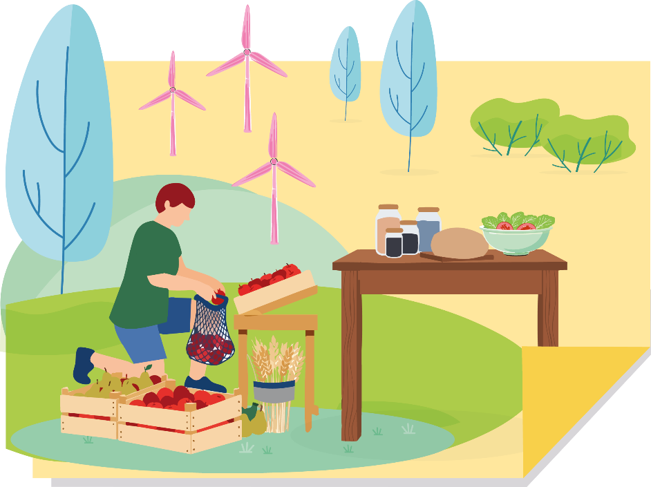

We eat well and sustainably, with climate and nature in mind

Q3.1 Please tell us to what extent you, or your organisation, agree that the statement above presents a positive future for Bath and North East Somerset

Please tick one:
- Strongly agree
- Agree
- Neutral
- Disagree
- Strongly disagree
- I don’t know

Q3.2 To what extent do you agree or disagree with the following ways to achieve this?
We need to:
- improve awareness of what planet-friendly food is, and support people to access it
- create more opportunities to grow food within communities so that we eat more local, plant-based foods

Please tick one:
- Strongly agree
- Agree
- Neutral
- Disagree
- Strongly disagree
- I don’t know

Q 3.3 Do you have any suggestions as to how you might improve the ‘The food we eat’ theme?

Q4 Our water and rivers

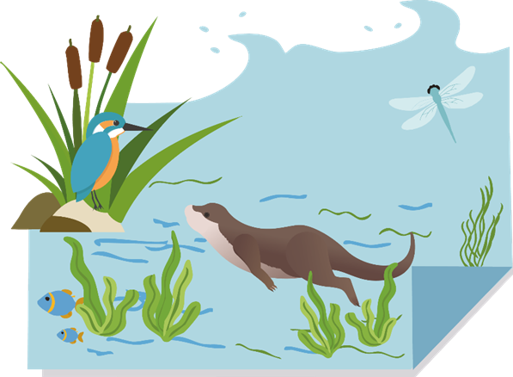
Our rivers and streams are clean and full of life

Q4.1 Please tell us to what extent you, or your organisation, agree that the statement above presents a positive future for Bath and North East Somerset

Please tick one:
- Strongly agree
- Agree
- Neutral
- Disagree
- Strongly disagree
- I don’t know

Q4.2 To what extent do you agree or disagree with the following ways to achieve this?
We need to:
- significantly reduce pollution into our rivers and streams
- slow the flow of water throughout the landscape using natural solutions to minimise flooding
- reduce the amount of fresh water we use and waste

Please tick one:
- Strongly agree
- Agree
- Neutral
- Disagree
- Strongly disagree
- I don’t know

Q 4.3 Do you have any suggestions as to how you might improve the ‘Our water and rivers’ theme?

Q5 Our wildlife and land

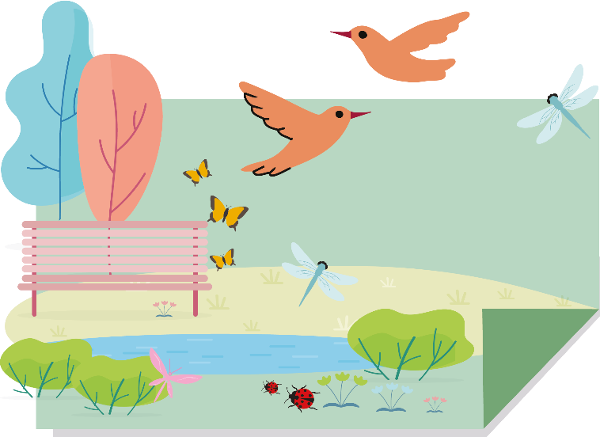

Wildlife is thriving

Q5.1 Please tell us to what extent you, or your organisation, agree that the statement above presents a positive future for Bath and North East Somerset

Please tick one:
- Strongly agree
- Agree
- Neutral
- Disagree
- Strongly disagree
- I don’t know

Q5.2 To what extent do you agree or disagree with the following ways to achieve this?
We need to use our land better. This means:
- creating more space for nature
- adapting to the changing climate
- providing food security in a way that is sustainable

Please tick one:
- Strongly agree
- Agree
- Neutral
- Disagree
- Strongly disagree
- I don’t know

Q 5.3Do you have any suggestions as to how you might improve the ‘Our wildlife and land’ theme?

Q6 The energy we use
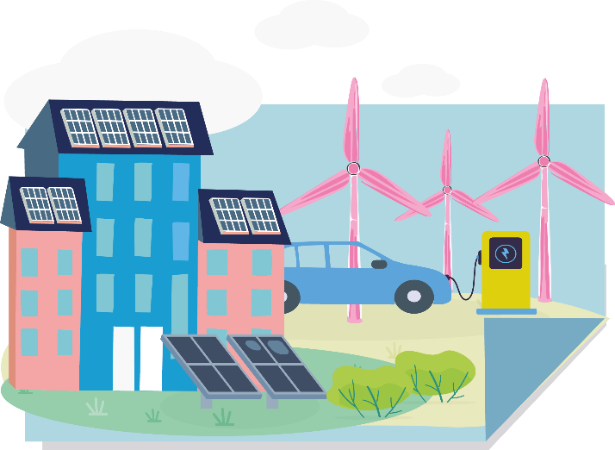

The energy we use is renewable, reliable and affordable

Q6.1 Please tell us to what extent you, or your organisation, agree that the statement above presents a positive future for Bath and North East Somerset

Please tick one:
- Strongly agree
- Agree
- Neutral
- Disagree
- Strongly disagree
- I don’t know

Q6.2 To what extent do you agree or disagree with the following ways to achieve this?
We need to move to clean energy. This means:
- wasting less energy
- replacing fossil fuels with renewable energy
- using local, community and regional energy sources where we can, making our contribution to national energy security

Please tick one:
- Strongly agree
- Agree
- Neutral
- Disagree
- Strongly disagree
- I don’t know

Q 6.3 Do you have any suggestions as to how you might improve the ‘The energy we use’ theme?

Q7 Our buildings and the built environment around them

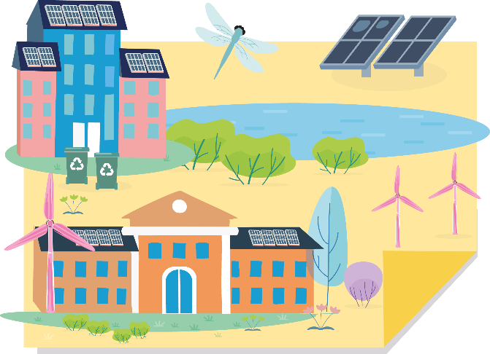

Our homes, workplaces and schools are comfortable, healthy and energy efficient

Q7.1 Please tell us to what extent you, or your organisation, agree that the statement above presents a positive future for Bath and North East Somerset

Please tick one:
- Strongly agree
- Agree
- Neutral
- Disagree
- Strongly disagree
- I don’t know

Q7.2 To what extent do you agree or disagree with the following ways to achieve this?
We need to:
- adapt our buildings and built environment to warmer, wetter winters and hotter, drier summers
- new buildings must be energy efficient to build and run
- all buildings need to be heated and powered by clean energy
- our buildings and built-up places must make enough room for wildlife to thrive

Please tick one:
- Strongly agree
- Agree
- Neutral
- Disagree
- Strongly disagree
- I don’t know

Q 7.3 Do you have any suggestions as to how you might improve the ‘Our buildings and the built environment around them’ theme?

Q8 Our local economy including tourism

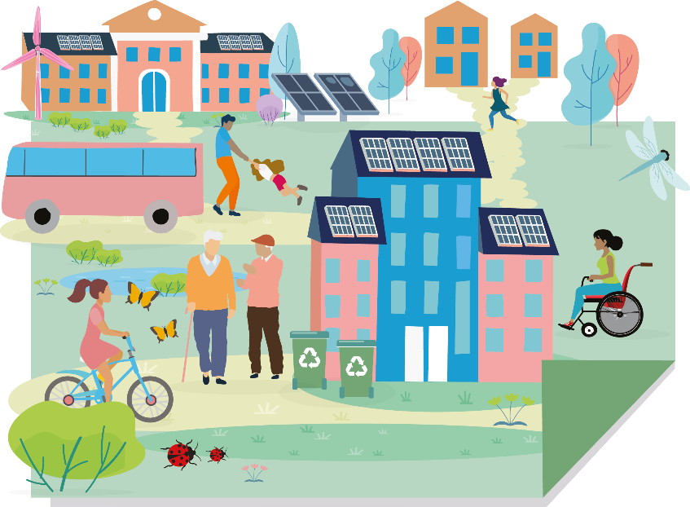

Our neighbourhoods and local economy are connected, green & ready for the future

Q8.1 Please tell us to what extent you, or your organisation, agree that the following statement presents a positive future for Bath and North East Somerset

Please tick one:
- Strongly agree
- Agree
- Neutral
- Disagree
- Strongly disagree
- I don’t know

Q8.2 To what extent do you agree or disagree with the following ways to achieve this?
We need to:
- make our neighbourhoods greener and more connected
- futureproof our local economy
- reduce the impacts of our businesses’ supply chains within and beyond our borders
- enable our visitors to act sustainably through the experience and choices we offer

Please tick one:
- Strongly agree
- Agree
- Neutral
- Disagree
- Strongly disagree
- I don’t know

Q 8.3 Do you have any suggestions as to how you might improve the ‘Our local economy including tourism’ theme?

Q9 The resources we use and waste we produce

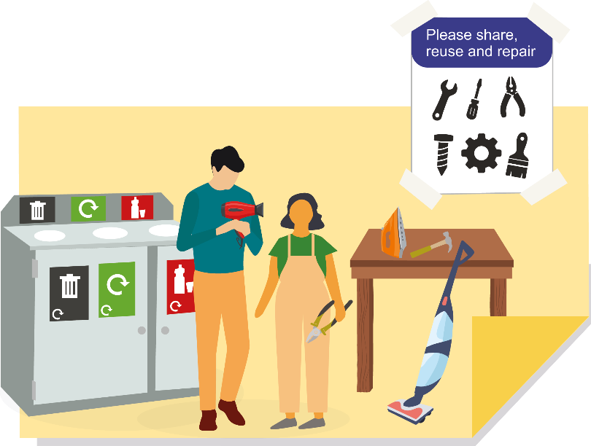
Sharing more, buying and wasting less is our normal

Q9.1 Please tell us to what extent you, or your organisation, agree that the statement above presents a positive future for Bath and North East Somerset

Please tick one:
- Strongly agree
- Agree
- Neutral
- Disagree
- Strongly disagree
- I don’t know

Q9.2 To what extent do you agree or disagree with the following ways to achieve this?
We need to:
- consume and waste less
- get used to re-using, sharing and mending more
- shift our local economy towards lowering its impacts on climate and nature

Please tick one:
- Strongly agree
- Agree
- Neutral
- Disagree
- Strongly disagree
- I don’t know

Q9.3 Do you have any suggestions as to how you might improve the ‘The resources we use and waste we produce’ theme?

Q10 A Fair Transition
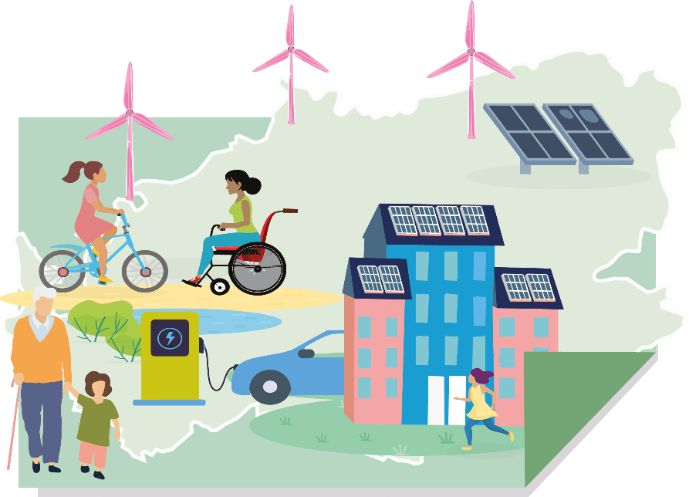

How we live and work reduces the impacts we have within and beyond our borders

Q10.1 Please tell us to what extent you, or your organisation, agree that the statement above presents a positive future for Bath and North East Somerset

Please tick one:
- Strongly agree
- Agree
- Neutral
- Disagree
- Strongly disagree
- I don’t know

Q10.2 To what extent do you agree or disagree with the following ways to achieve this?
Our actions should help make life better for everyone. We need to:
- work with communities to understand how the Climate and Nature Emergencies affect people and places differently
- focus on supporting those who are most vulnerable and least able to adapt

Please tick one:
- Strongly agree
- Agree
- Neutral
- Disagree
- Strongly disagree
- I don’t know

Q 10.3 Do you have any suggestions as to how you might improve the ‘Fair Transition’ theme?

Q11 How we prepare for the long-term
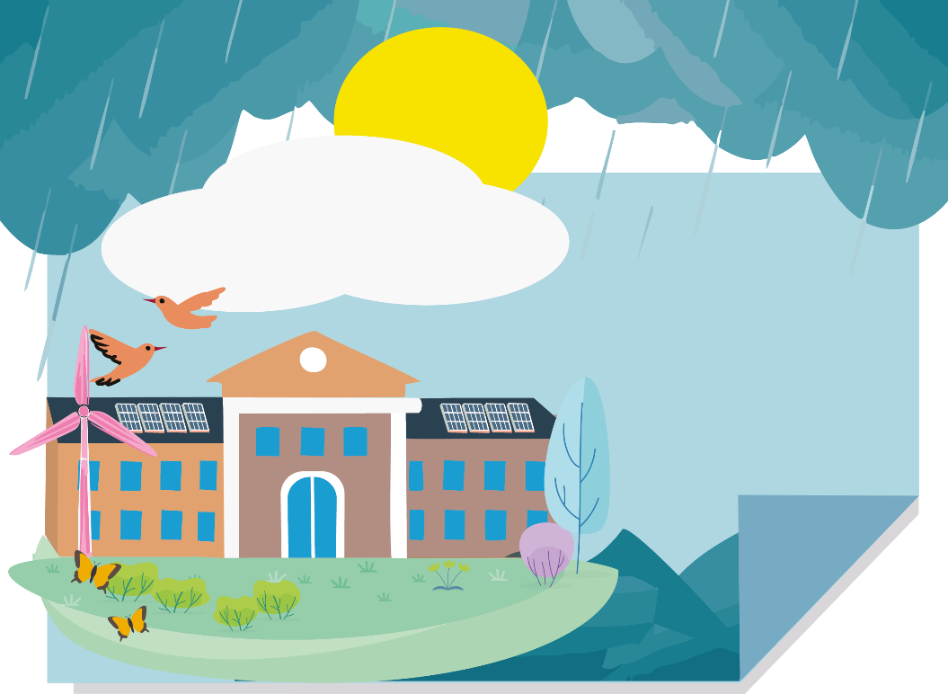

We are adaptable to the impacts of a changing climate, including increased flooding, extreme heat & drought

Q11.1 Please tell us to what extent you, or your organisation, agree that the statement above presents a positive future for Bath and North East Somerset

Please tick one:
- Strongly agree
- Agree
- Neutral
- Disagree
- Strongly disagree
- I don’t know

Q11.2 To what extent do you agree or disagree with the following ways to achieve this?
The actions in our plan will build our resilience as a community for the long-term. They will:
- restore nature
- reduce emissions
- reduce risk
- increase equity
- and support local for delivery

Please tick one:
- Strongly agree
- Agree
- Neutral
- Disagree
- Strongly disagree
- I don’t know

Q11.3 Do you have any suggestions as to how you might improve the ‘How we prepare for the long-term’ theme?

Q12 Are there any themes missing that you think we should include?

Section 3: How do we make change happen?
Q13. What are the right priorities to help make change happen across Bath and North East Somerset?
Please tell us how important or unimportant the following would be to you or your organisation

Prioritising action in local communities – streets, neighbourhoods or places
- Very important
- Quite important
- Neutral
- Not very important
- Not important at all
- I don’t know

Supporting businesses to act
- Very important
- Quite important
- Neutral
- Not very important
- Not important at all
- I don’t know

Supporting individual action, for example funds to help upgrade homes
- Very important
- Quite important
- Neutral
- Not very important
- Not important at all
- I don’t know

Civic action, for example between the council and large organisations
- Very important
- Quite important
- Neutral
- Not very important
- Not important at all
- I don’t know

The council leading by example in its own green spaces, buildings, services
- Very important
- Quite important
- Neutral
- Not very important
- Not important at all
- I don’t know

Growing partnerships to accelerate change, both in Bath and North East Somerset and beyond
- Very important
- Quite important
- Neutral
- Not very important
- Not important at all
- I don’t know

Increasing financial support (e.g. grants, incentives, affordable options, new financial models & partnerships)
- Very important
- Quite important
- Neutral
- Not very important
- Not important at all
- I don’t know

Focusing on supporting the right skills and jobs
- Very important
- Quite important
- Neutral
- Not very important
- Not important at all
- I don’t know

Influencing decisions beyond the local area, for example regional or national government
- Very important
- Quite important
- Neutral
- Not very important
- Not important at all
- I don’t know

Are there any other priorities missing that you think we should include?

Section 4: Any further feedback on this subject
Q4. Is there anything else you think is important for the future of climate and nature action in Bath & North East Somerset that we haven’t asked about?

